UNIT 2 RESEARCH ASSIGNMENT:

TYPE – RESEARCH

OUTCOMES TO BE ASSESSED:
Outcome 1: Investigating and Communicating

Outcome 2: Structure, Properties and Uses of Materials

ADDITIONAL EVIDENCE:

Outcome 3: Interaction and Change

ESSENTIAL CONTENT - UNIT 2
The practice of chemistry
Models theories and language
Chemistry in and around the Home
VALIDATION

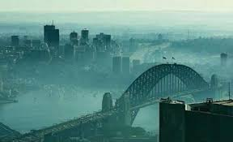

OPEN QUESTION: Energy and fuel value

- What does the term sustainable mean? Give an example from your studies. [2 marks]

Sustainable means to maintain at a constant level [1]
Eg. To keep our fuel resources at a maintained level [1] or any suitable correct example.

- Outline how we refine oils to obtain the vast variety of hydrocarbon fuels. Draw a labelled [1] diagram [1]of the equipment used. [3 marks]

Fractional Distillation – boiling point [1]
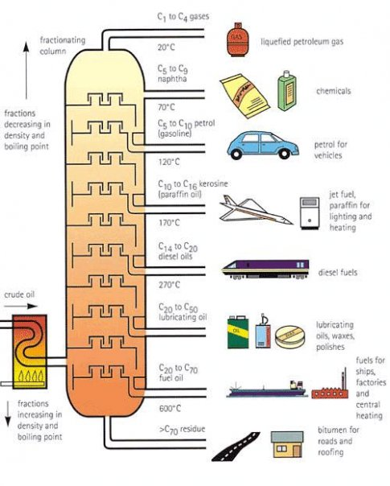

- Describe how biofuels such as bioethanol are most commonly made.
[2 marks]
Fermentation [1] using yeast [1]

- Draw a balanced chemical equation for octane burning in air [1 mark]

C₈H₁₈ + 25O₂ → 16CO₂ + 18H₂O

- Complete the following equation:

- _2__C₃H₈ + ___7O₂__ → 6 CO + 8 H₂O [1 mark]
- What would you define this type of reaction as? [1 mark]

Incomplete combustion

- Would there be more or less of an enthalpy change in this reaction? Explain why. [2 marks]

Less. [1] bonds formed to bonds broken ratio is less so the net change in energy is less [1].

- Draw a balanced chemical equation for ethanol burning in air [1 mark]

CH₃CH₂OH + 3O₂ → 2CO₂ + 3H₂O

- As you can see below, the enthalpy of combustion values for the two fuels are significantly different.

∆H_{c} of Ethanol = 1360 kJ/mol & Density = 0.79g/cm³
∆H_{c} of Octane = 5460 kJ/mol & Density = 0.70g/cm³

Compare the energy from 10mL of each fuel to determine which fuel is more efficient at providing energy. [5 marks]

m(CH₃CH₂OH) : 10mL = 7.9g
n(CH₃CH₂OH) = m / Mr = 7.9g / 46 = 0.1717 moles [1]
∆H = 1360 x 0.1717 = 233.56 kJ [1]

m(C₈H₁₈) : 10mL = 7.0g
n(C₈H₁₈) = m/Mr = 7 / 114 = 0.0614 moles [1]
∆H = 5460 x 0.0614 = 335.3 kJ [1]

C₈H₁₈ > CH₃CH₂OH [1] in quantity of energy per 10 mL

- Compare and contrast the fuels in terms of carbon footprint and efficiency to generate an opinion on which fuel is “best” to use.
[5 marks]
Ethanol produces ¼ the amount of CO₂ per molecule to octane [1]
∆H_{c} of Ethanol = 1360 x 4 = 5440 kJ [1]
Opposed to Octane = 5460 kJ for the same carbon footprint [1]

In low concentrations of oxygen ethanol is more likely to completely combust [1]
Best to use as it is more efficient at producing energy. [1]
Ethanol production and combustion is carbon neutral [1]
Octane comes from crude oil that takes millions of years to make. [1]
Bioethanol is expensive to produce [1] octane is cheap [1]

